As per java docs, during serialization, runtime associates with each serializable class a version number, called a serialVersionUID, which is used during de-serialization to verify that the sender and receiver of a serialized object have loaded classes for that object that are compatible with respect to serialization. If the receiver has loaded a class for the object that has a different serialVersionUID than that of the corresponding sender’s class, then de-serialization will result in an InvalidClassException. A serializable class can declare its own serialVersionUID explicitly by declaring a field named “serialVersionUID” that must be static, final, and of type long:
private static final long serialVersionUID = 4L;

Here, the serialVersionUID represents your class version, and you should increment it if the current version of your class is modified such that it is no longer backwards compatible with its previous version.
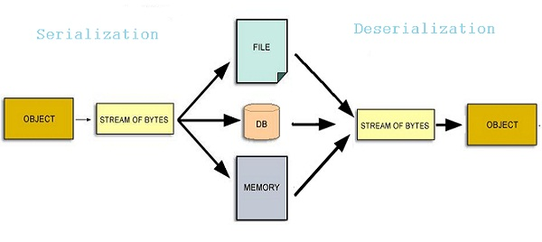
Lets see an example of how a class is serialized and then de-serialized:
If a serializable class does not explicitly declare a serialVersionUID, then the serialization runtime will calculate a default serialVersionUID value for that class based on various aspects of the class.

Joshua Bloch says in Effective java that the automatically-generated UID is generated based on a class name, implemented interfaces, and all public and protected members. Changing any of these in any way will change the serialVersionUID.

However, it is strongly recommended that all serializable classes explicitly declare serialVersionUID values, since the default serialVersionUID computation is highly sensitive to class details that may vary depending on compiler implementations and can produce different serialVersionUID in different environments. This can result in unexpected InvalidClassException during de-serialization.
Therefore, to guarantee a consistent serialVersionUID value across different java compiler implementations, a serializable class must declare an explicit serialVersionUID value. It is also strongly advised that explicit serialVersionUID declarations use the private modifier in serialVersionUID where possible, since such declarations apply only to the immediately declaring class. SerialVersionUID field is not useful as inherited member.

